Cuba’s Green Revolution
The balm to the Achilles heel of Castro’s Revolution
By Geoff D’Arcy, Lic. Ac., D.O.M.

Looking out across the organic medicinal herb farm in the Pinar del Rio province of Cuba, I am intoxicated by the scent from endless rows of German chamomile, calendula, and Japanese mint. This state-run 200-acre organic farm, known as the “Finca Provincial Plantes Medicinal,” grows medicinal herbs used by the Cuban Ministry of Public Health for distribution throughout pharmacies, hospitals and clinics in the Cuban healthcare system. This is one of the largest medicinal herb farms in the 14 provinces of Cuba, and, according to its director, Sergio Travieso Sanchez, this farm and many others like it are growing by 20 to 25 percent a year.
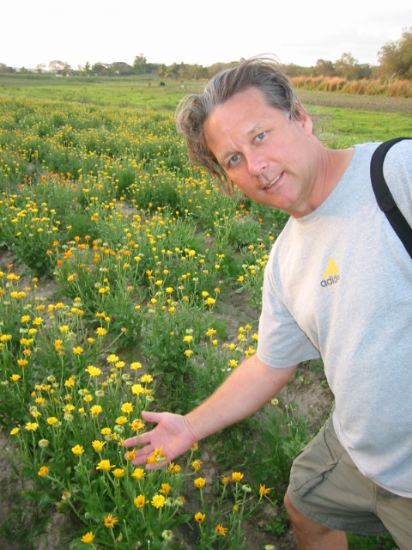 | 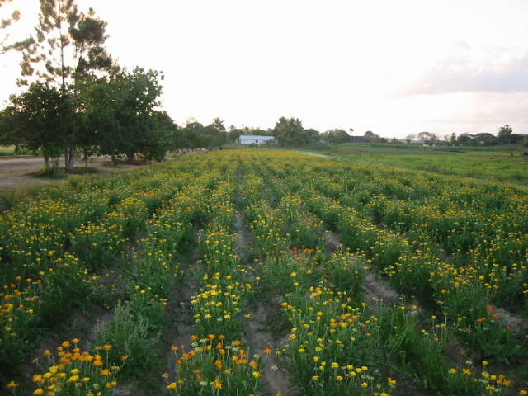
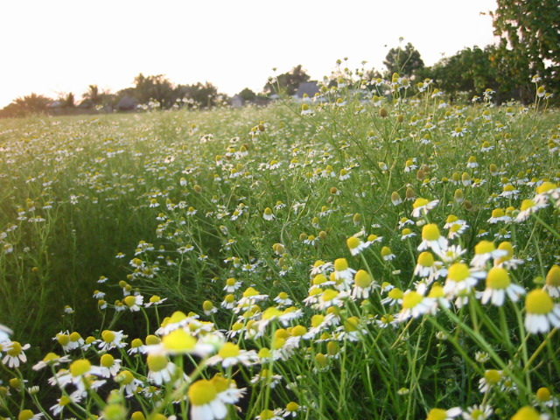 | 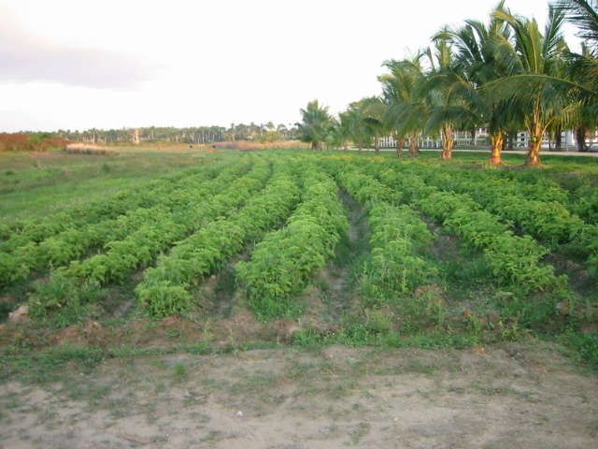
‘Vinca de Provincial Plantes Medicinal’ Herb Farm.

Beginning in 1990, Raul Castro, brother of Fidel Castro, wanted to rescue the Cuban tradition of herbal medicine to provide natural medicines for its healthcare system. The immaculately maintained farm has grown from a modest four crops in its first year to a spectacular 45 crops in 2003, and has continued to grow with a small staff of only 45 workers and with no machinery. (By government mandate, only oxen are permitted for use in the fields.) As I watched the soft crimson sunset bathe the fields in a golden light, I could almost feel the purity of the herbs and the power of their medicinal value.

This State farm has to be independently profitable; its main contracts come from the Ministry of Health. The major herbs grown for use by the Ministry this season include oregano, calendula, Japanese mint, German chamomile, aloe vera, eucalyptus, banana leaves, and turmeric. Director Sanchez tells us they have two seasons that are carefully planned around the Ministry’s crop requirements. He hopes that with more land and the possibility of using machinery in the fields, he may be able to keep up with the growth and success of his country’s “green medicine” (medicine verde) revolution.

Green medicine in Cuba is not a gentle holistic trend, but born of the stark reality of economic collapse, as pharmacy and hospital shelves became empty of expensive pharmaceutical drugs. For the last ten years, the Cuban government has endorsed and aggressively promoted the cost-effective medicine provided by herbs, homeopathy and acupuncture.
Before the economic crises of 1990-92, Cuba had a “sweet” sugar deal with the Soviet trading bloc, which virtually turned the island into Russia’s sugar “plantation.” From 1960 to 1990, Cuba was highly dependent on the Soviet bloc, importing petroleum, pharmaceuticals, equipment, chemical fertilizers, pesticides, and food (even importing up to 57 percent of its calories). Amazingly, the sweet deal with Soviet trading bloc had made it cheaper for Cuba to export sugar and import all of its basic foods.
Then in 1990 came the political and economic implosion of the Soviet Bloc and Cuba’s sweet sugar deal turned really sour. Almost overnight, Cuba lost five billion dollars’ worth of Soviet support, and its Soviet-style agriculture, with its heavy use of chemicals, ground to a halt. The Torricelli Act further tightened the screws of an already existing US trade embargo, curtailing shipments of food and medical supplies from subsidiaries of American companies. Food was scarce, pharmacy shelves were empty, and there was little fuel for transportation. Life got tougher when, during the hot, humid Cuban summer, only a few hours of electricity per day were allowed to run fans and refrigerators.

Cuba’s response to the “Special Period” was already bubbling under the surface of its culture. In medicine, acupuncture training was already established in military hospitals. In rural areas, the use of herbal medicine was growing, and in agricultural communities, young scientists were agitating for less dependence on agro-chemical imports and wanting to explore organic farming techniques. This crisis, caused by financial dependence on the Soviets and importation of food and medicine, was the unforeseen weak-spot in the Revolution, and ironically is what turned it “green.” The green revolution in agriculture and medicine, along with tourist dollars, has become the healing balm to the “Achilles heel” of Castro’s Revolution.

In 1995, under the direction of Dr. Leoncio Padron Caceres, within the Ministry of Public Health the new Office of Natural and Traditional Medicine was created. Dr. Padron is committed to an accelerated program of growth for the development of holistic medicine, as well as its integration with conventional medicine. Throughout Cuba, each neighborhood has what is called a "green pharmacy," where alternative medicines, which compensate for unaffordable pharmaceuticals, are made and sold.. Doctors write prescriptions for medicines like oregano extract (used to reduce the frequency of epileptic seizures), and ‘Imefarma,’ a traditional Cuban herbal formula for asthma, that is made from eucalyptus and banana leaves.

Green medicine has taken hold in a healthcare system dominated by a scientific approach. Physicians and nurses are now offered four-year specialty training in traditional Chinese medicine, as well as two-year master’s programs and various courses and seminars for the “barefoot doctor” approach, all taught by expert doctors from China, North Korea and Vietnam.
In a recent press release, Juana Irene, an expert with Cuba’s Natural and Traditional Medicine Program, said, "Though traditional Chinese medicine has been in Cuba for 150 years, Cuban hospitals and drugstores normally don't sell it because it hasn't formally entered the Cuban market. Noting that traditional Chinese medicines are popular in Cuba, Juana Irene said that approximately one million Cubans annually tried acupuncture and Cuba bought traditional medicinal materials from China, valued at 60 million U.S. dollars each year. The Cuban government encouraged Chinese experts to set up clinics and schools in Cuba, to introduce new herbal medicines, to develop traditional Cuban medicine, and to cooperate with Cubans in producing traditional medicine.”
Experts in Cuba report the integration of alternative and conventional medicines is a good approach; it will last beyond any economic improvement. Even if the U.S. embargo lifted tomorrow, and pharmaceuticals were freely available to Cubans, many experts believe that green medicine is here to stay. Dr. Leoncio Padron, National Director of Traditional Medicine, said in a recent CNN interview, “If we wake up one day to this good news, we would still continue with traditional and natural medicine as part of the same arsenal.”

Las Terrazas Eco-Tourism Community
When the Soviet subsidies were slashed, 900 people in the Las Terrazas EcoTourism community lacked ample food or medicine and were limited to what they were permitted to take from their biosphere reserve The government then decided to build the Hotel Moka to develop tourism. Now eco-tourists like myself venture into the lush forests for treks and swims. Staying in the thatched huts by the river, we were lulled to sleep by the symphony of sounds from the lush forest. Although Las Terrazas is not a typical Cuban community, it was fascinating to see how its health needs were interlinked. The clinic, school and a rare commodity in Cuba -- a vegetarian restaurant -- were all used as community assets.

Las Terrazas’s Green Clinic
Even though the clinic’s dispensary shelves were empty, we did find in stock some
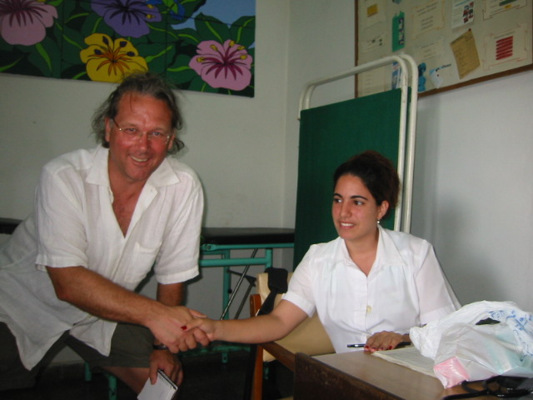 | 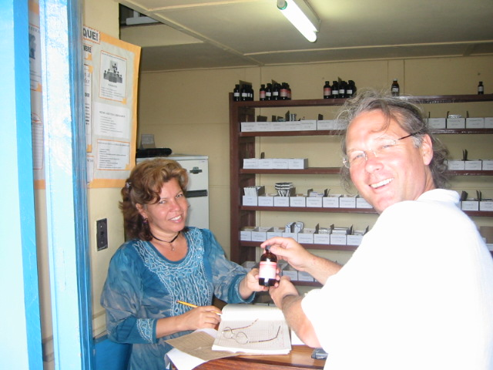
Dr. Lisbett Dias at the rural Las Terrazas clinic.  At the Clinic in Las Terrazas in the province of Pinar del Rio, known locally as Cuba's "garden province." | Rosa Barrionvero, now mainly dispenses herbal medicine for around 80 cents and has some pharmaceutical that are also sold.
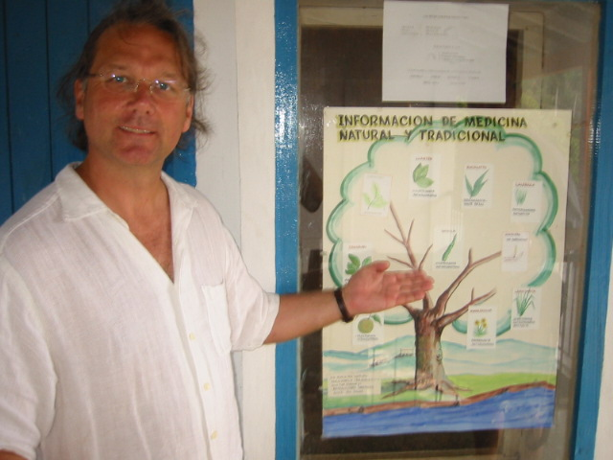 | 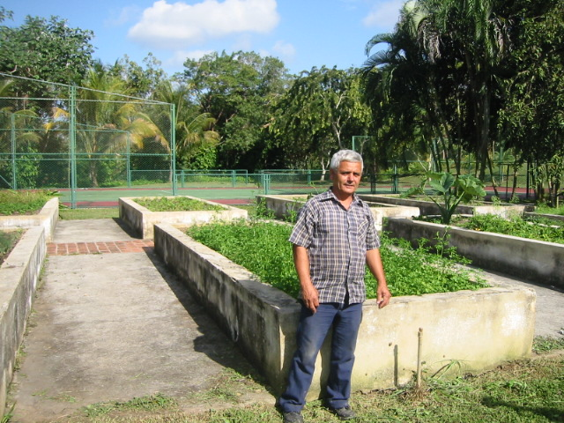
An herbal education charts the Las Terrazas clinic. Las Terrazas is Cuba's first UNESCO-sanctioned biosphere reserve. | Herb Farmer Taino Reyes, supplied the vegetarian restaurant and Hotel in Las Terrazas , an eco tourism resort in the province of Pinar del Rio.
homeopathic medicine and herbal tinctures, herbal teas. The community’s school teaches herbal healthcare lessons, and children learn not only how to use medicinal herbs, but also how to grow them in the school garden.
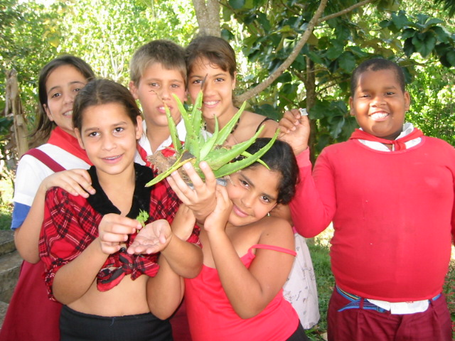 | 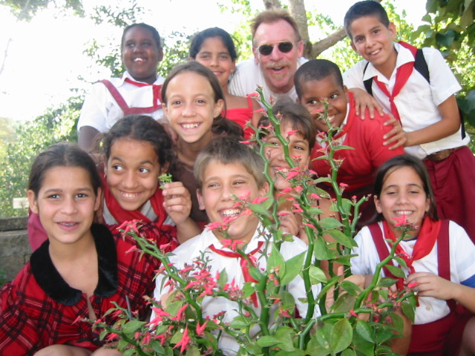
Aloe Vera in the School’s Medicinal Herb Garden. | The kids show us medicinal plants they were taught how to use and prepare.
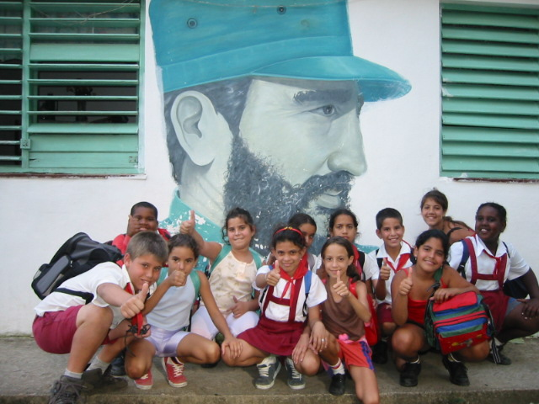 | 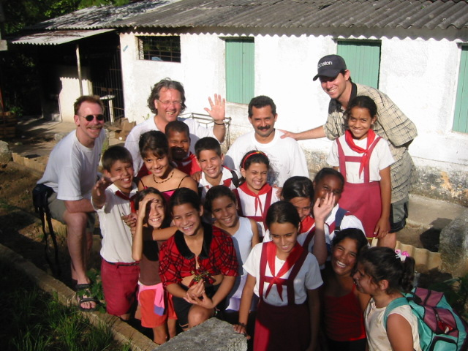
Republica Oriental Del Uraguay School kids, in front of a mural of Fidel. | Our group, with the kids and their principle Daniel Perez

According to Dr. Lisbett Dias, at least 30 to 40 plants are commonly used for medicine by the locals. These herbs come from individual gardens in the community and are prepared either as teas, tinctures, ointments or creams. The clinic also offers acupuncture, carried out by technicians with the minimum training. Dr. Dias, like all doctors trained in Cuba today, has a few months’ training in green medicine, though she admitted she was not as confident in green medicine as her predecessor was.
The emphasis of care here is clearly on prevention. It is impressive to note that everyone receives a yearly check-up. Biannual exams are offered to Cubans in risk groups such as smokers and alcohol abusers. Three check-ups a year are provided for those with diagnoses such as hypertension and diabetics. Prevention clubs for the elderly, pregnant women, and teenagers. The whole community has access to acupuncture, herbal medicine and homeopathy, even if on a crude level. The two doctors and two nurses of this rural clinic suggest cooking classes at the vegetarian restaurant for those with diabetes and hypertension.
The local school, “Republica Oriental Del Uraguay,” at Las Terrazas was vibrant and noisy as children poured out at the end of the day. Daniel Perez, the school principal,
explained that his students are taught how to use plants for common problems as part of the school curriculum. The children were proud to show us their medicinal herbal garden. As part of the prevention theme, at-risk children, with problems such as obesity, receive counseling and encouragement from the school’s therapist to change cooking and eating habits at home.

The Vegetarian Restaurant ‘El Romero’ (Rosemary)
On the veranda overlooking a lush forest we enjoyed a bountiful lunch as the founder of the vegetarian restaurant “El Romero,” Tito Nunez Gudas, guided us through course after delicious course. Tito is transforming the classic Cuban diet that is typically heavy with fried food, pork, fried plantains, fried vegetables, rice, and beans, and very few fresh fruits and vegetables. Vegetarianism is very strange to Cubans. “In fact,” Tito laughed, “as a child, when I asked my uncle what a vegetarian was, he replied that is was a mad man who only eats oranges.”

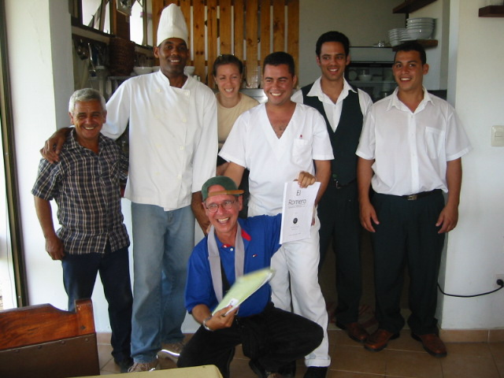 | 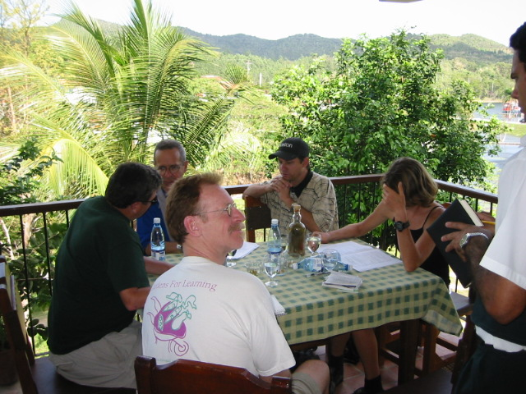
The founder Tito Nunez Gudas (holding their amazing menu) and staff of El Romero vegetation restaurant, Las Terrazas. | Our group enjoys remarkable vegetarian cuisine on the terrace of El Romero restaurant

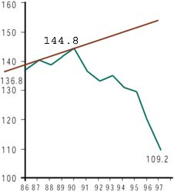
After using vegetarianism to help him overcome his own health problems, Tito became a committed vegetarian and went on a health crusade to found three vegetarian restaurants. Without vegetable and fruits in their diets to provide the necessary fiber and essential vitamins and other nutrients, Cubans experience the same rates of cancer and heart disease as other industrialized nations. In a recent poll conducted by the governmental Institute of Nutrition and Food Hygiene, it was reported that less than one percent of those surveyed said they would prefer a menu without animal protein, while 62 percent reported that they rarely or never ate fresh salads. It is an uphill battle for Tito that is getting a helping hand from the crisis. Beef, being resource heavy, is reserved almost exclusively for hotels and restaurants catering to foreigners. In fact, beef is presently illegal for Cubans, who can be arrested for having the meat in the refrigerator. With meat harder to come by, people are eating lots more homegrown vegetables and fruits, and the Cuban people are almost reluctantly becoming healthier. Vegetable output in Cuba climbed from 36 kg per person in 1995 to around 99 kg in 2000. The decreased intake of dietary saturated fats, a less sedentary lifestyle and a lower incidence of obesity, has helped to promote a dramatic decrease in heart disease by at least 25 percent. Tito’s expertise is in demand, yet with Cuba’s Communist policies as they are, his restaurants have to be supported by the government. He is lucky to have a brother of a “Hero of the Revolution” (Osmani Cienfuegos) as a benefactor to help his work.

The Cuban diet is becoming greener and healthier (whether Cubans like it or not.) In my opinion, if more Cubans could just taste the delicious food served here on this veranda in Tito’s restaurant, they would become willing converts.

Cuba’s herbal medicine; a blend of herbal traditions
Just like the rich history of Cuba’s racial melting pot, herbal traditions are blended from many cultures. Spanish and European influences are mixed with those of the original Taino and Caribe Indians. West African slaves brought their own special infusion to the herbal mixing pot. When slavery was abolished in 1868 and the dark history of slavery ended, some 150,000 indentured Chinese laborers were brought to work the sugar plantations from Canton, and brought with them their own traditional Chinese herbal medicines. Today there is still a thriving Chinatown in Havana. Exploring the synthesis of traditions is an approach very dear to the heart of Dr. Carlos Manuel Mendez. Like myself, he is interested in how to guide locally grown herbs into formulas according to the principles of traditional Chinese medicine, and to bring this approach into the mainstream medical system. I expect this will be the next chapter in Cuba’s herbal history and the logical progression for a country that lets very little of is traditions go to waste and has such rich herbal pharmacy in its own back yard.

Integrating Green Medicine in Cuba’s Hospitals
Walking into Havana’s International Center for Neurological Restoration (known locally as CIREN), is like walking from a Third World country into a modern hospital. Like many of Cuba’s innovative hospitals, CIREN has opened its doors to tourists as part of the country’s need for dollars. This sophisticated 250-bed hospital is a leader in some research and treatments. It has a staff of 11 neurologists and three neurosurgeons, additional anesthesiologists, internists, pediatricians, gerontologists, psychiatrists and psychologists, 82 neuro-rehabilitation specialists, and a nursing staff of over 100. It specializes in the treatment and rehabilitation of people with neurological injuries and illnesses, whether from disease or injury. Doctors are using fetal stem cells, a controversial technology in the US, to try to restore brain and nerve function in victims of accidents and in sufferers of diseases such as Parkinson’s. CIREN is also developing an integrative green medicine, holistic approach. Foreign and Cuban patients receive treatments, after being evaluated by expert neurologists and MDs with green medicine backgrounds.
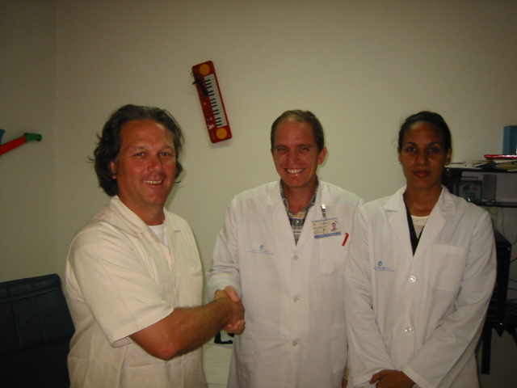 | 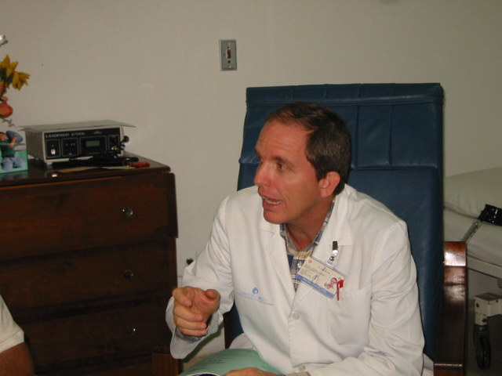
Dr. Tahimi Cardiso integrates Bach flower remedies, Homeopathy with Transactional analysis into her work at Havana’s International Center for Neurological Restoration, | Dr. Carlos Manuel Mendez a Cuban pioneer of Acupuncture also practices Herbal Medicine. He is head of the Department of Traditional Chinese Medicine at Havana’s International Center for Neurological Restoration,
Dr. Carlos Manuel Mendez, a Cuban pioneer of acupuncture, practices herbal medicine and heads up CIREN’s green medicine department. He helps shape treatment plans recommended by colleagues. Together with Dr. Tahimi Cardiso, these bright compassionate doctors are on a mission to prove to their colleagues that green medicine works and to confirm results with documentation and further research.

In most countries, such labor-intensive therapy would cost a small fortune. In Cuba, the treatment is affordable because the country has a surplus of highly educated medical specialists (166 people per doctor) who earn next to nothing ($25 a month for most doctors). Patients are assigned multidisciplinary teams of experts, from psychologists to language rehabilitation specialists, as well as physical therapists. After a week of consultation, patients undergo at least 28 days of treatment and rehabilitation, although the majority of patients stay three to six months, or as long as a year. Treatment costs vary, according to a patient’s country of origin. For example, Americans pay about $11,000 for a five–week program, citizens of Third World countries pay less, and Cubans pay nothing, if they can get in.

Cuba’s Food Farming Produces 100% Organic Vegetables
In response to the “Special Period” the government offered huge financial incentives to farmers, outside of the established 5-tier pay system, just to be able to feed the people. In the words of Pablo Frias, a farmer, “food is a matter of life and death,” and the incentives worked! In Havana there are now estimates of 8,000 organic “victory gardens.” These farm/gardens are producing a million tons of food annually. They range in size from a few feet to several acres.
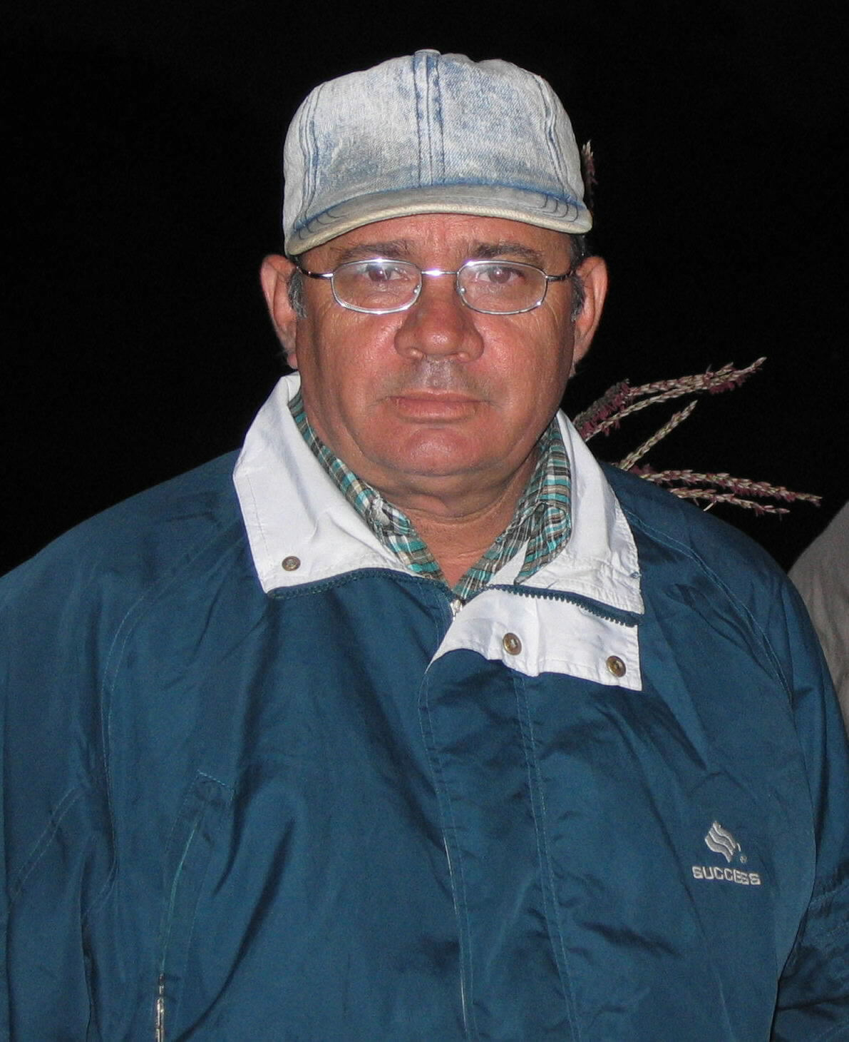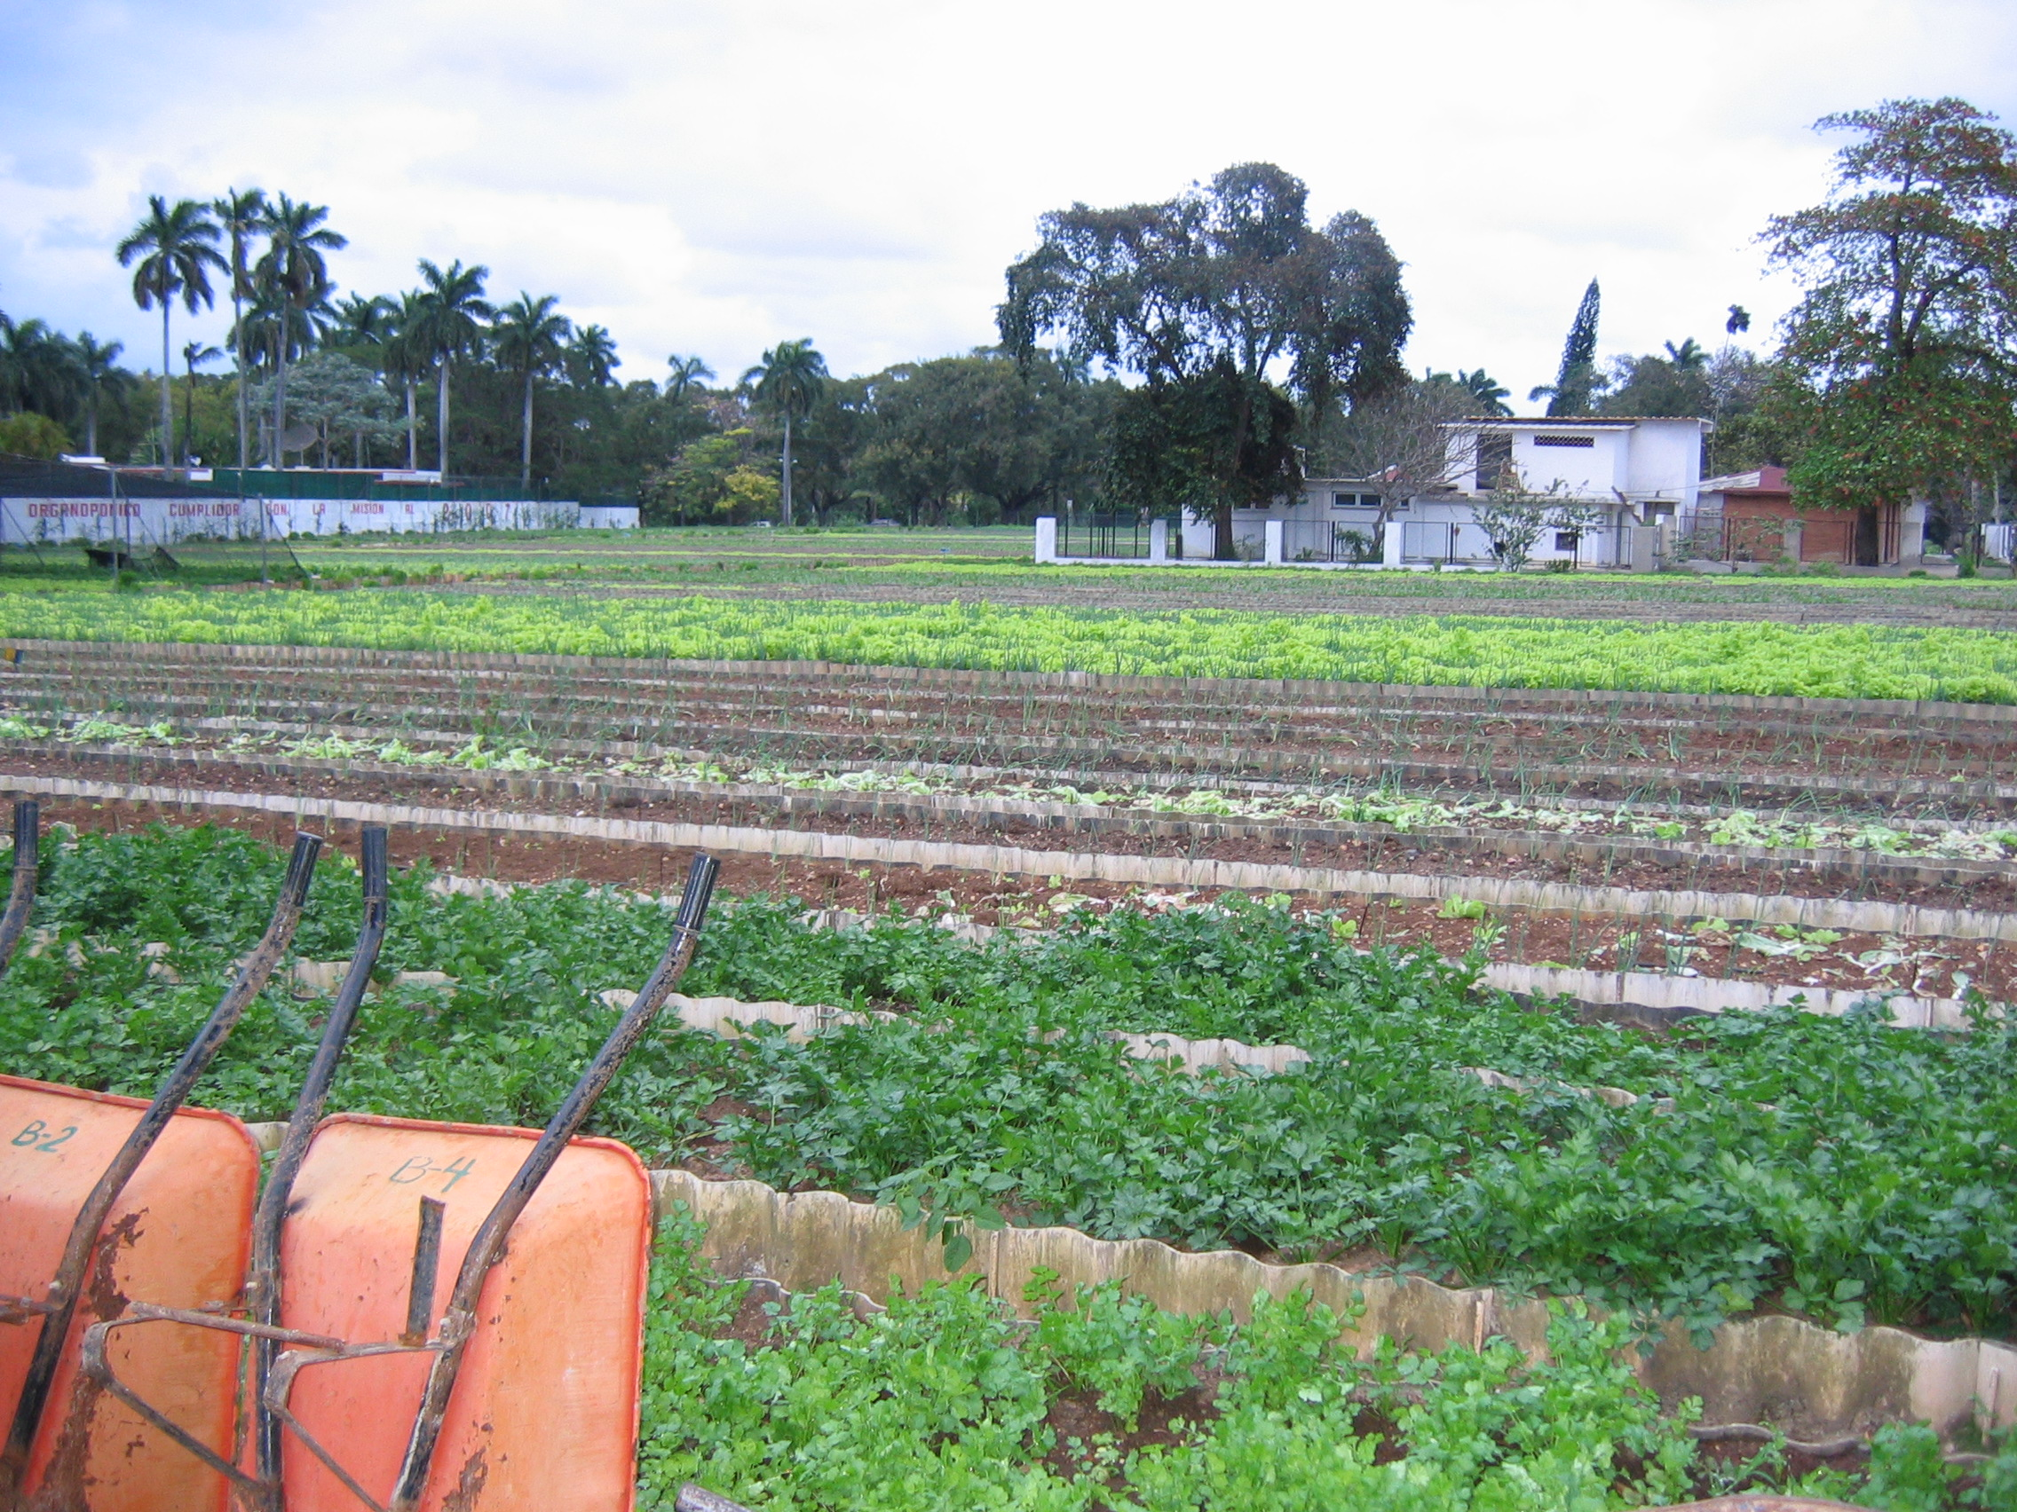 | 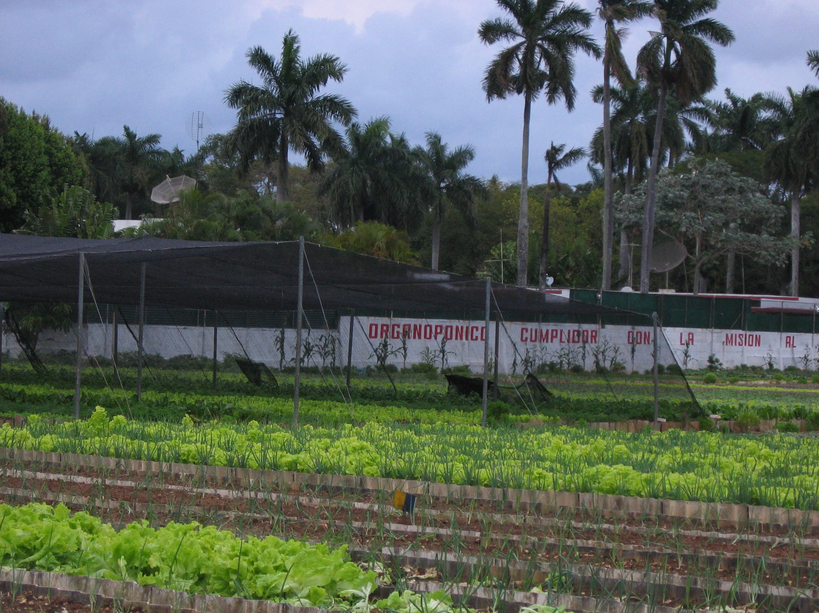
Senor Pablo Frias, Director of the ‘Organoponico Cumplidor’, an urban organic farm in Havana
Urban farmers, like Senor Frias, are primarily growing lettuce, bok choy, onions, chard, radishes, tomato, cabbage and broccoli. Gardens can employ anywhere from one to 70 people depending on the size of the garden. Pablo Frias describes himself as a typical urban farmer. A former Army officer forced out of retirement by the need to make ends meet, Pablo started his farm from scratch, on land destined for a medical school building. What farms like these have achieved is to produce twice as much food with less than half the chemical inputs. Before the crises, Cuban agriculture was technically similar to California, dependent on mechanization, artificial fertilizers and insecticides that put the soils into poor condition, sterilized by agrochemical inputs and salinised? by excessive irrigation.
Cuba, in an unprecedented move in the modern history of agriculture, switched almost overnight to organic farming practices. Today the vegetables in Cuba are reported to be an astounding 100% organic and GMO free. Oxen have replaced tractors for plowing and transporting crops. Organic integrated pest management replaced pesticides; crop rotation, composting and soil conservation re-fertilized the soil. Government research institutes were set up to develop more sophisticated techniques of worm composting, soil inoculants and bio-pesticides. Over 200 bio-pesticides production centers were set up.

Cuba’s organic farming system is successful, and Cubans appear to be breaking apart the myth that “although organic farming is good for the planet, yields would not sustain Earth’s population.” Here, yields have been increased through organic farming techniques, a much cheaper alternative to conventional agrochemicals. Cuba’s farming is cocooned and tucked away from the world, in an environment free of the pressures and demands of the agro-business marketplace. Lessons have been learned in this experiment that can be shared with farmers around the world.
When asked what he would do if the embargo were lifted and he had the dollars to spend on improving his farm, farm director Pablo Frias said, “We would not revert to the old methods if they became available tomorrow.” It seems that the revolution to organic farming has changed business as usual, and this innovation will not be relinquished. If necessity is the mother of all inventions, then the economic crises that created these inventive innovations have pushed Cuba out into new territory, and the entire world can benefit from their experiment.

At the end of our journey, whilst sitting and relaxing with Cuban cocktail on the terrace of the 1930’s El National Hotel, music of the Buena Vista Social Club wafting in the evening air, I was reflecting back on our fact finding mission to Cuba. It occurred to me that if Castro’s dependence on imported food and medicine proved to be the revolution’s Achilles heel that inflamed the entire body of the society, then the green revolution
(Along with tourism) has proved to be its innovative healing balm. This is the kind of healing from which we all can benefit.

About the Author,
Geoff D’Arcy has been a licensed acupuncturist and herbalist for 23 years. He practices at the D’Arcy Wellness Clinic in Natick, Ma. Geoff is a new herbal product consultant to international companies and President of D’Arcy Naturals herbal supplement company for people and their pets.

References
Fig 1. Mortality Rates from Ischemic Heart Disease in Cuba from 1986 to 1997 (adjusted to 1981 population)
1. The Greening of the Revolution. Ocean Press.Edited by Peter Rosset and Medea Benjamin.
2. Mortality from ischemic heart disease in Cuba. The role of diet and serum cholesterol Prof. Alberto Hernández Cañero, M. D. , Ph.D. http://www.medicc.org/Medicc%20Review/II/heart/html/mortality.html
3. A Green Revolution. http://www.cosg.supanet.com/greencuba.html
4. The Big Green Experiment: Cuba's Organic Revolution
Lisa Van Cleef http://yeoldeconsciousnessshoppe.com/art9.html
5. Cuba's national program for hypertensionhttp://www.medicc.org/Medicc%20Review/II/heart/html/spotlight_on.html
6. Cuba's security in fresh produce
By Eliza Barclay Environmental News Network http://www.enn.com/news/2003-09-12/s_8194.asp
7. "Dreaming with Two Feet on the Ground: Acupuncture in Cuba"
by Harriet Beinfield, LAc http://www.geocities.com/waves_of_hope/acupuncture/
8. http://english.peopledaily.com.cn/200207/03/eng20020703_99055.shtml
9. Cuba’s diet; http://www.ibike.org/cuba/library/CU%20diet.rtf

